Discovering the Artist Inside: A Three-Step Approach to Predictable Aesthetic Smile Designs, Part 2
Dent Today. 2013 Jul;32(7):126, 128-31.
Written by Galip Gürel, DDSThursday, 18 July 2013 08:30

INTRODUCTION
An aesthetic smile is harmonious with the facial characteristics and beauty of each individual. Many factors come together to create a smile that suits the face and personality of each individual, including the dentist’s perception, talent, artistic flare, and skills in listening to the specific desires of the patient. It is most desirable to create a new smile with minimal tooth reduction, using a restorative material that produces highly aesthetic results with long-term clinical predictability.¹
The aesthetic pre-evaluative temporaries (APT) technique, as introduced in part 1 of this article series (Dentistry Today, May 2013), was developed to evaluate the final aesthetic design prior to tooth preparation. This concept has proven extremely beneficial for addressing key factors such as patient concern, design limitations, and functionality before treatment has been initiated and, most importantly, it ensures minimally invasive tooth preparation.¹⁻⁴
The long-term clinical success rate of ceramic porcelain restorations has been well documented.⁵⁻⁷ Modern ceramics provide dentists restorative materials that are capable of creating teeth with a natural, lifelike appearance. Lithium disilicate glass ceramic offers accuracy of fit, shape, and function. This modern all-ceramic material is available in various shades and different degrees of opacity and translucency, while providing strong mechanical properties able to withstand the rigors of the oral environment. Delivering these restorations using an adhesive bonding system produces a highly predictable and long-lasting clinical outcome.
The following clinical case depicts the use of this aesthetic restorative material while using a 3-step process for minimal tooth reduction.
CASE REPORT
A healthy female patient presented with a chief complaint of a compromised aesthetic smile (Figure 1). She exhibited short clinical crowns, and our initial conversation revealed that she was also unhappy with the color of her teeth.
Clinical examination revealed attrition along the incisal edges of both the maxillary and mandibular anterior teeth. Additionally, the patient had existing composite resin restorations with compromised margins on the mesio-facial of tooth No. 8 and also on the distal-facial of tooth No. 9 (Figures 2a and 2b).
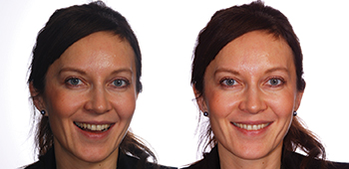
﻿Figure 1. Preoperative photos.
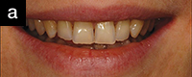
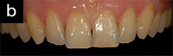
﻿Figures 2a and 2b. Preoperative intraoral photos representing attrition at incisal edges of maxillary(a) and mandibular teeth and composite restorations on teeth Nos. 8 and 9 (b).
Step One: Patient Communication and Mock-Up
As mentioned in part 1 of this series, personal communication with the patient is of the utmost importance.^{1,8} During this communication, open-ended questions relative to the patient’s feelings about the teeth and smile should be asked. An open-ended question cannot be answered with “yes” or “no,” but rather invites patients to express their viewpoint in greater detail. This offers the opportunity for patients to share their true feelings toward treatment and provides guidance to the clinician concerning their expectations.
Cooperation and communication between the dentist and the patient, in conjunction with excellent communication between the doctor and laboratory team, will determine the success or failure of the treatment. The dentist’s perception of a desirable smile and the style of design should be discussed with the patient and be considered along with the patient’s personal thoughts on his or her appearance. Styles that are unrealistic for the frame and form of the patient’s face should be discussed and avoided.¹
A breakdown of communication occurs when the dentist places emphasis on his or her own opinions and references rather than on the expectations and desires of the patient.⁹ A result that is aesthetically pleasing to the dentist may not always be in tune with the wishes of the patient. This is due to the fact that the patient’s aesthetic understanding often differs from that of the clinician. Understanding that each patient is an individual with specialized circumstances and backgrounds will assist the dentist inproviding truly unique treatment plans.¹
An easy and effective way for patient visualization of smile design and final outcome is by preparing an intraoral composite resin mock-up. Depending on the clinical parameters, a new smile design for the entire maxillary arch can be achieved within 5 to 20 minutes. Composite materials offer the advantage of using likenesses in shade and thickness of the final restoration. In this way, the patient is able to get an accurate 3-dimensional image of the anticipated final restoration and the dentist is, at the same time, able to define the incisal length, positioning, and plane. The mock-up is also helpful when establishing the lateral, central incisor relationships and their axial inclinations.¹
In the this case, a composite mock-up (TetricEvoCeram [Ivoclar Vivadent]) was created by using the freehand carving method.¹⁰ First, composite resin was rolled between the fingers and applied directly onto the dried tooth surface without an adhesive. Then, the desired tooth form (Figures 3a to 3e) was aesthetically designed by way of the fingers/specialized hand instruments and light-cured (Bluephase G2 [Ivoclar Vivadent]).
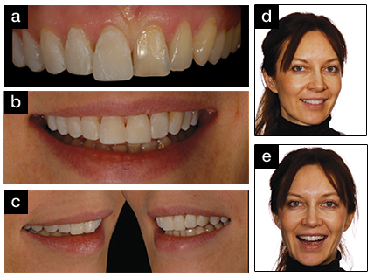
﻿Figures 3a to 3e. Intraoral mock-up was prepared by veneering composite resin over existing teeth without use of adhesive agent. Lengthening of the clinical crowns was performed, per patient’s chief complaint (a to d). Patient’s facial profile pictures after mock-up (e).
Once both the patient and dentist agreed upon the smile design, clinical photographs were taken along with a digital video recording. A vinyl polysiloxane impression (such as Honigum [DMG America], AFFINIS [Coltène], Virtual [Ivoclar Vivadent], Imprint 3 [3M ESPE], Flexitime [Heraeus Kulzer], or Chromaclone [Ultradent Products]) was then taken of the composite mock-up in order to transfer the incisal edge position, facial contours, and inclination to the dental laboratory team.
Critical to successful communication between the dentist and the technician are the use of mounted diagnostic casts and a diagnostic wax-up. The use of these tools allows the dentist and the laboratory technician to visualize the expected result. The study casts taken during the initial visit are utilized for the foundation of the wax-up or replica of the anticipated final restorations. The design and the fabrication of the wax-ups are vitally important, since the spatial orientation and architectural dimensions of the wax-up will be used to formulate the preparation limits. The provisional will also be made from the template that is an exact duplicate of the wax-ups. Therefore, special care should be taken by the technician during this process to ensure that the final wax-up is aesthetically pleasing as well as functional1 (Figures 4a to 4d).
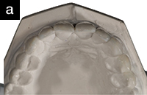 | 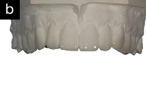
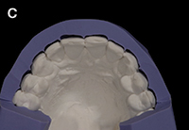 | 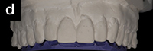

﻿Figures 4a to 4d. Prepared wax-up by dental laboratory (a and b). Fabrication of silicon index from laboratory wax-up and its application over the model of the existing dentition. Note the additive spaces gained by additive nature of the mock-up and wax-up (c and d).
Step Two: Aesthetic Pre-Evaluative Temporaries
One predictable and easy technique is to use the silicon index for fabrication of APT restorations.² As mentioned in part 1 of this series, APT restorations are created before treatment planning has been finalized. As APTs are completed before any tooth preparation is done and the patient is anesthetized, they allow the patient to see and experience the smile design: the smile-line, the lip posture, phonetics, function, and, most importantly to the patient, the aesthetic outcome.
Silicon indices allow the clinician to judge the spacing that has already been created by the additive mock-up and also guides the clinician about the extent of crown lengthening required for achieving desired aesthetic results (Figure 5a). When the silicon index is placed over the existing teeth, it’s possible to see the spacing that has been created by the additive mock-up and the parallel wax-up. Another index can be used to see how much the teeth will be lengthened. When the index is returned to the patient’s mouth, plenty of spacing is evident, indicating minimal preparations will be required.
From the laboratory wax-up, transparent templates and silicon indices were fabricated (Figure 5b). A transparent impression material (such as R.S.V.P. [Cosmedent], Memosil [Heraeus Kulzer], Elite Glass [Zhermack], or Matrix flow 70 clear [Anaxdent]) is preferred for a number of reasons. The first reason is so that the final outcome is visible as soon as the APT is in place. Transparent silicon material allows the dentist to see any voids that may be found in the APT. Thus, before polymerizing the material, the index can be removed, refilled, and returned to the mouth. Transparent material also allows the clinician to use resin-based light-cured provisional materials, further decreasing chair time.
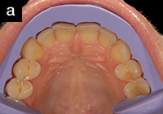 | 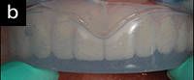

﻿Figures 5a and 5b. Silicon indexes were used as guidance for facial contour, incisal edge position and guides minimum tooth reduction (a). Transparent silicon index was used to prepare aesthetic pre-evaluative
temporaries (APT) (b).
Afterward, a bis-acryl provisional material (Luxatemp [DMG America]) was injected into the silicon index and seated over the patient’s dentition. Once the material had polymerized, the silicon index was removed from patient’s mouth showing newly formed APT with contours that mimicked the patient’s current contours, enlarged teeth, and an enhanced color (Figures 6a to 6e).
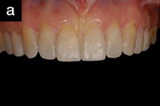 | 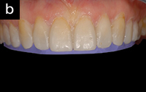
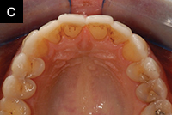 | 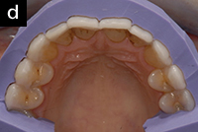

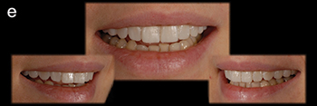

﻿Figures 6a to 6e. Aesthetic pre-evaluative temporaries were prepared by injecting provisional material in silicon index and seating it over patent’s dentition. Contours and crown lengths were confirmed using silicon matrix(a to d). Aesthetic outcome after placement of APT (e).
Step Three: Tooth Preparation
The silicon index and APT fit perfectly within the patient’s mouth both facially and incisally. After positioning the APTs correctly, an appropriate depth cutter (828.31.026 [Brasseler USA]) was selected to prepare the horizontal depth cuts and incisal reduction (5856.314.018 [Brasseler USA]). Afterward, the depths are filled in with pencil for reference (Figures 7a to 7b). When both horizontal and vertical depth cuts were completed, the APT was removed to allow a determination of the areas where prep was (or was not) needed. An ultrasonic diamond tip (Piezo Prep 227-KaVo Piezo Ultrasonic Scaler [KaVo]) was used for minimal prep of the interproximal and gingival margins. This tool creates smooth chamfers while preventing damage to the adjacent teeth (Figures 8a to 8e).
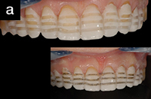 | 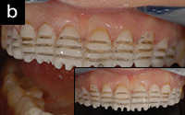

﻿Figures 7a and 7b. Horizontal and incisal tooth cuts were made on APTwith depth cutters. Pencil was used to pinpoint the depth created by depth cutter.
The surface of each tooth was smoothened and polished with an Arkansas stone (1715.04.025 [Brasseler USA]). Then, to round any sharp incisal edges or corners that could potentially cause internal stresses in the lithium disilicate veneers, a sandpaper disk was used to round all sharp edges. Finally, the interproximal prep lines were checked to see if they were in contact with one another. If the lines are in contact, a separator is used to create a minor space. A separator ensures that the completed margin preparations will not be affected when the lab is breaking the contacts to create the dies. If the prep lines are touching each other in the lingual/palatal dimension, the lab will most likely damage the contact. In this clinical case, the teeth were fairly flat, so the interproximal preps were extended, bringing them into contact with the adjacent tooth. Therefore, separators were used in the interproximal areas.
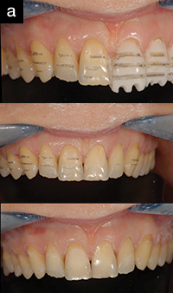

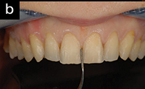 | 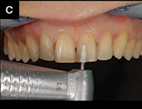
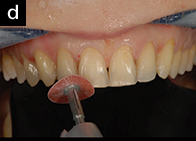 | 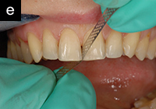

﻿Figures 8a to 8e. Pencil marks on tooth structure after removal of APT that was used as a depth guide for tooth preparation (a). Interproximal and gingival margins were smoothened
(b to e).
Checking with different indices will confirm the preparations are good facially and lengthwise (Figures 9a and 9b). In this case, minimal tooth preparation was achieved, and all of the tooth preps were contained within the enamel.^{2,14} Finally, an impression was made of the preparation using the sandwich technique¹¹ (Figure 10). Impressions should not be taken in the presence of active bleeding, other fluid contamination, or when the soft tissues are compromised. A face-bow (UTS Universal Transfer System Facebow [Ivoclar Vivadent]) was also created to transfer the position of the arch (Figure 11). A shade guide (VITA Classical Shade Guide [Vident]) was used to determine the desired color and this shade, the stump shade, all study models, impressions and clinical photographs were provided to the ceramist for creation of the final restoration.
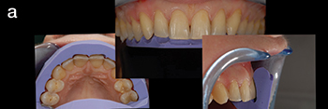
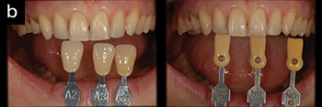
﻿Figures 9a and 9b. Tooth reduction was checked using silicon indices (a). Final restoration shade and stump shade was selected (b).
The standard process to place a provisional has been to spot etch the middle one third of the tooth, place an adhesive, and on top of that, adhere the provisional. Afterward, any flash present at the gingival margins would need cleaning. This cleaning presents 2 potential dangers. The first danger is the potential for bleeding during cleanup. The second potential danger is damage to the prepped margins caused by the bur used to remove the flash.
A technique introduced by Dr. Robert Nixon¹² ensures that the soft tissues remain intact, eliminating the potential for bleeding when preparing provisional restorations. This technique is extremely beneficial in cases where veneers will be placed quickly and soft tissues would be kept untouched, thus eliminating the need for injured soft tissue to heal. The procedures allow the build-up of the provisional while protecting gingival margins and eliminating the possibility of the provisional delaminating.
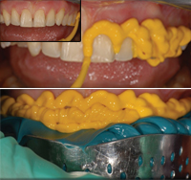 | 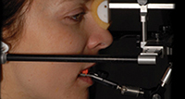
﻿Figure 10. Impressions were made using the sandwich technique. | ﻿Figure 11. Face-bow transfer.

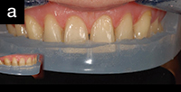 | 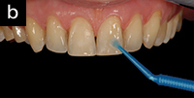

﻿Figures 12a and 12b. Fabrication of provisional restorations using the R.S.V.P. technique (Cosmedent). Silicon matrix was placed one to 2 mm away from soft tissues (a). Adhesive was applied to prepared teeth (b).

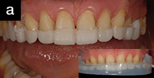 | 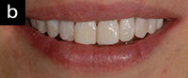

﻿Figures 13a and 13b. Fabrication of provisional restorations using the R.S.V.P. technique. Provisional restorations were prepared on incisal and middle third of prepared teeth (a) followed by building up on cervical third(b).
This technique was used to create the final provisionals for this patient. The silicon impression used in creation of the APT was used to create a horizontal cut 1.0 to 2.0 mm coronally away from the soft tissues or the tip of the papilla (Figures 12a and 12b). A disinfecting agent (Consepsis [Ultradent Products]) was then applied to the tooth. R.S.V.P. was injected into the silicone index and placed over the dentition. The gingival one third now looked exactly like the APT. The final incisal embrasures, as well as the incisal design of the one third, were examined, and then the material was light-cured (Figures 13a and 13b).
The key to using this technique is that nothing should be in contact with the soft tissues. When light-cured, the polymerization process shrinks the material, creating mechanical interlocking which will be difficult to remove. This interlocking mechanism prevents the provisional from falling out.
Selecting the most suitable restorative material assists in achieving predictable results. A pressable ceramic gives one of the best fitting veneer options.¹³ By using the proper techniques during preparation, impression taking, and wax-up, the restorative material is able to easily provide the aesthetics and function. With pressable ceramics, the process is easily achieved in 3 steps: build up the cores, invest it, and press it. A strong glass ceramic material, such as the pressable lithium disilicate material used in this case (IPS e.max Press [Ivoclar Vivadent]), can be prepared very thin while providing a strong core that serves as a solid foundation for the application of aesthetic layering porcelains (Figure 14). Bit by bit, layer by layer, following the design of the wax-up or the APT, the ceramist builds up the veneers using the indexes provided to him as guides (Figure 15). As one can see, in this case, the result was a very nice restoration that mimics the APT.
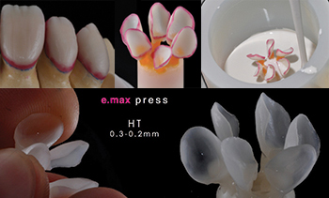
﻿Figure 14. Lithium disilicate (IPS e.max Press [Ivoclar Vivadent]) veneer cores were pressed.
Delivery of the Final Restorations
Although veneers can hold well in the patient’s mouth at the try-in stage, most patients are not able to correctly judge the aesthetic outcome when laying back on the chair to keep the veneers in place. Try-in gels (pastes) provide a way to overcome this issue. Gels not only stabilize the veneers, but also give the exact result or look of the veneers after bonding, providing a more accurate aesthetic picture for the patient. Gels also allow a better assessment because they will hold the veneer in place even if the patient stands up. This allows the patient to talk and smile naturally, which can be digitally photographed (or recorded on video) to show to the patient (Figure 16).
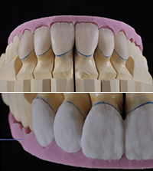 | 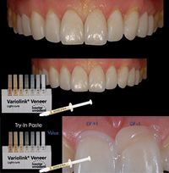
﻿Figure 15. Aesthetics were then optimized via the addition of layering porcelains. | ﻿Figure 16. Veneers were bonded in using a light-cured resin cement (Variolink Veneer [Ivoclar Vivadent]).

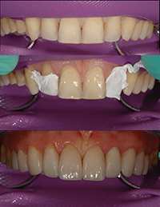
﻿Figure 17. Final cementation of the lithium disilicate (glass ceramic) veneers.
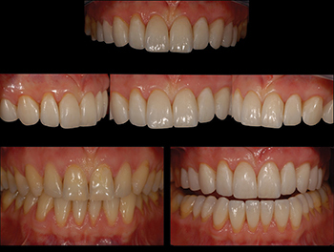
﻿Figure 18. Postoperative photos.
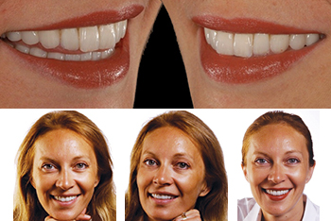
﻿Figure 19. Postoperative photos.
The author’s preference in bonding multiple veneers is to place the veneers 2-by-2. In this way, the 2 centrals, then a lateral and a canine from one side, then a lateral and a canine from the other side, and then each set of premolars are bonded. Care should be given to protect the adjacent tooth with the help of Teflon tape while etching or applying adhesive to the teeth. Proper isolation (rubber dam) helps to avoid contamination from saliva (Figure 17). If the correct bonding technique was used, the margins should look great even if the rubber dam is still in the mouth just few minutes after the time of bonding. During this clinical case, the veneers were bonded using a light-cured resin cement (Variolink Veneer [Ivoclar Vivadent]). Shades of resin cement were selected using Variolink Veneer try-in paste.
The result was a smile with longer crowns with a slight color change meeting the expectations of the patient (Figures 18 and 19).
CONCLUSION
Aesthetic smile design and treatment have 2 major components/objectives. The first is the way in which the clinician communicates with the patient and the laboratory team. Instead of using just verbal communication, one can easily and visually communicate via an intraoral mock-up, a diagnostic wax-up, and an APT (placed in the patient’s mouth before any injection and tooth preparation).
The second is to preserve as much healthy tooth structure as possible. This can be achieved by preparing the tooth through the APTthat in most cases allows the dentist to remain on/within the enamel. The more additive the APT is the more minimally invasive it will be.
If the above steps are carefully applied, the final restorations will not only appear very aesthetic, they will also be very long lasting.
Acknowledgement
The author wishes to thank to the ceramist, Hilal Kuday (Istanbul, Turkey), for all of the hard work to prepare these beautiful restorations.

References
- Gürel G. The Science and Art of Porcelain Laminate Veneers. Chicago, IL: Quintessence Publishing; 2003.
- Gürel G, Morimoto S, Calamita MA, Coachman C, Sesma N. Clinical performance of porcelain laminate veneers: outcomes of the aesthetic pre-evaluative temporary (APT) technique. Int J Periodontics Restorative Dent. 2012;32:625-635.
- Magne P, Belser UC. Novel porcelain laminate preparation approach driven by a diagnostic mock‐up. J Esthet Restor Dent. 2004;16:7-18.
- Magne M, Magne P, Cascione D, et al. Optimized laboratory-fabricated provisionals. Dental Dialogue. April 2006;6:68-77.
- Wolfart S, Eschbach S, Scherrer S, Kern M. Clinical outcome of three-unit lithium-disilicate glass-ceramic fixed dental prostheses: up to 8 years results. Dent Mater. 2009;25:e63-e71.
- Guess PC, Strub JR, Steinhart N, Wolkewitz M, Stappert CF. All-ceramic partial coverage restorations—midterm results of a 5-year prospective clinical splitmouth study. J Dent. 2009;37:627-637.
- Della Bona A, Kelly JR. The clinical success of all-ceramic restorations. J Am Dent Assoc. 2008;139(suppl):8S-13S.
- Pietrobon N, Paul SJ. All‐ceramic restorations: a challenge for anterior esthetics. J Esthet Dent. 1997;9:179-186.
- Goldstein RE. Study of need for esthetics in dentistry. J Prosthet Dent. 1969;21:589-598.
- Dietschi D. Free-hand composite resin restorations: a key to anterior aesthetics. Pract Periodontics Aesthet Dent. 1995;7:15-25.
- Duarte S Jr, Vilarreal E, Tada T, et al. Sandwich technique for minimal invasive bonded porcelain veneers. dmg-dental.com/downloads/user-reports. Accessed April 9, 2013.
- Nixon RL. Provisionalization for ceramic laminate veneer restorations: a clinical update. Pract Periodontics Aesthet Dent. 1997;9:17-27.
- Schaefer O, Watts DC, Sigusch BW, Kuepper H, Guentsch A. Marginal and internal fit of pressed lithium disilicate partial crowns in vitro: a three-dimensional analysis of accuracy and reproducibility. Dent Mater. 2012;28:320-326.
- Gürel G, Sesma N, Calamita MA, Coachman C, Morimoto S. Influence of enamel preservation on failure rates of porcelain laminate veneers. Int J Periodontics Restorative Dent. 2013;33:31-39.

Dr. Gürel graduated from the University of Istanbul Dental School in 1981. He continued his education at the University of Kentucky, department of prosthodontics, and received his MS degree from Yeditepe University, Istanbul. Dr. Gürel is the founder and the honorary president of EDAD (Turkish Academy of Aesthetic Dentistry). He served as the president of the European Academy of Esthetic Dentistry in 2010 and 2011 and is a member of the American Society for Dental Aesthetics, American Academy of Restorative Dentistry, and an honorary Diplomate of the American Board of Aesthetic Dentistry. Dr. Gürel is a visiting professor of New York University, Marseille Dental University (France), and Yeditepe University (Turkey). Additionally, He is the author of The Science and Art of Porcelain Laminate Veneers (Quintessence, 2003), which has been translated into 10 different languages. He can be reached at dentis@superonline.com.
Disclosure: Dr. Gürel lectures for Ivoclar Vivadent and Sirona Dental Systems.

